# LOVELY BOUTIQUE WEB

# A PROJECT REPORT

***Submitted by***

# P. L. N. Priya

***in partial fulfilment for the award of the degree*** ***of***

# BACHELOR OF TECNOLOGY

**IN**

**COMPUTER SCIENCE AND ENGINEERING**

**SPECIALIZATION IN ARTIFICIAL INTELLIGENCE AND MACHINE**

## LEARNING



# Lovely Professional University, Punjab

**OCTOBER 2024**

**Lovely Professional University, Punjab**

# BONAFIDE CERTIFICATE

Certified that this project report **“... LOVELY BOUTIQUE …”**

## is the bonafide work of “... P. L. N. PRIYA ...”

who carried out the project work under my supervision.

**SIGNATURE**

**Dr. Jaibir Singh**

**ABSTRACT-**

### Lovely Boutique: Fashion And Beauty

### Project Overview

Create a visually appealing and user-friendly website for "Lovely Boutique," a fashion boutique designed to showcase a curated collection of stylish clothing and accessories. The website aims to provide users with a smooth browsing experience, highlighting product quality, style, and brand identity.

Fashion-conscious individuals seeking unique, trendy, and high-quality clothing and accessories. The target demographic includes young adults and middle-aged fashion enthusiasts.

### Project Objectives

1. Prioritizing recyclability,
2. Addressing social issues,
3. Using SMART goals,
4. Earning a profit,
5. Creating a cohesive brand identity,
6. Staying on top of trends.

### Expected Outcomes

### • Enhanced User Experience: A clean, stylish, and easy-to-navigate interface that provides users with a high-end, enjoyable browsing experience.

### • Engagement and Interaction: Interactive features powered by JavaScript, such as image sliders and hover effects, to keep users engaged and encourage them to explore more products.

### • Responsive Design: A fully responsive layout that adapts seamlessly to various devices, providing a consistent experience for mobile, tablet, and desktop users.

### • Product Showcase: A visually appealing presentation of products that highlights key items and collections, designed to attract customers and showcase the brand’s aesthetic.

### • Basic E-commerce Functionality: Essential features like a product gallery, shopping cart, and checkout process simulated to provide a realistic online shopping experience.

### • Professional Portfolio Piece: A polished, well-executed project that demonstrates skill in front-end development, styling, and website functionality—suitable for a professional portfolio.

### Conclusion

The "Lovely Boutique", where elegance meets exclusivity. We're committed to curating only the finest selections to elevate your style and confidence. Whether you're looking for timeless classics or the latest trends, our collection is designed to bring out the best in you.

We prioritize quality and customer satisfaction, making your shopping experience seamless and enjoyable. Explore, express, and enhance your wardrobe with *Lovely Boutique*—where every piece is crafted with you in mind.

**TABLE OF CONTENTS**

|  |  |
| --- | --- |
| **CHAPTER NAME** | **PAGE NO.** |
| **Title Page** | **1** |
| **Bonafide Certificate** | **2** |
| **Abstract** | **3** |
| **Table of Contents** | **4** |
| **CODES** | **5-39** |
| **OUTPUTS** | **40-43** |
| **List of Symbols, Abbreviations and Nomenclature** | **44** |
| **References** | **45** |

## CODES

### “Homepage.html”- HTML file

### home.html

<!DOCTYPE html>

<html lang="en">

<head>

    <meta charset="UTF-8">

    <meta name="viewport" content="width=device-width, initial-scale=1.0">

    <title>Complete Responsive E-Commerce Jewellery Website</title>

    <link rel="stylesheet" href="https://cdnjs.cloudflare.com/ajax/libs/font-awesome/5.15.4/css/all.min.css">

    <link rel="stylesheet" href="Homepage.css">

</head>

<body>

    <div class="modal" id="modal">

        <div class="container">

            <span class="close" onclick="closeModal()">&times;</span>

            <div class="image">

                <img src="Images/Subscribe image.png" alt="">

            </div>

            <div class="content">

                <h2>Subscribe to Lovely Boutique</h2>

                <p>stay updated with the latest trends and exclusive offers on our exquisite Trending collection</p>

                <form action="">

                    <input type="email" placeholder="Your Email Address" required>

                    <button type="submit" class="btn">Subscribe</button>

                </form>

            </div>

        </div>

    </div>

    <header>

        <div class="header-top">

            <div class="social">

                <a href="#" class="fab fa-facebook"></a>

                <a href="#" class="fab fa-twitter"></a>

                <a href="#" class="fab fa-pinterest"></a>

                <a href="#" class="fab fa-linkedin"></a>

            </div>

            <div class="alert">

                <p>

                    <b>Free Shipping</b> This week order over -  ₹99

                </p>

            </div>

            <div class="actions">

                <select name="currency">

                    <option value="rupee">INR &#8377;</option>

                </select>

                <select name="language">

                    <option value="en-US">English</option>

                    <option value="en-ES">Tamil</option>

                    <option value="fr">Telugu</option>

                </select>

            </div>

        </div>

        <div class="header-main">

            <div id="menu" class="fas fa-bars"></div>

            <a href="Images/LB Logo.png" class="logo"> <i class="fas fa-gem"></i>Lovely Boutique</a>

            <nav class="navbar">

                <a href="#home">Home</a>

                <a href="#about">About</a>

                <a href="#products">Product</a>

                <a href="#services">Services</a>

                <a href="#blogs">Blogs</a>

                <a href="#order">Order</a>

            </nav>

            <div class="icons">

                <button class="action-btn">

                    <a href="#" class="fas fa-user"></a>

                </button>

                <button class="action-btn">

                    <a href="#" class="fas fa-heart"></a>

                    <span class="count">0</span>

                </button>

                <button class="action-btn">

                    <a href="#" class="fas fa-shopping-cart"></a>

                    <span class="count">0</span>

                </button>

            </div>

        </div>

    </header>

    <section class="home" id="home">

        <div class="content">

        </div>

    </section>

### aboutus.html

 <section class="about" id="about">

        <h1 class="heading">About <span> Us</span></h1>

        <div class="row">

            <div class="image">

                <img src="Images/Model image.jpg" alt="">

            </div>

            <div class="content">

                <h3>elegence redefined, passion perfected</h3>

                <img src="Images/quote.svg" alt="" class="quote">

                <p> Lovely Boutique features an elegant design with high-quality images, a clean layout,

                    and intuitive navigation. Key sectionsoften include a homepage with featured

                    items or promotions, a catalog or shop section for browsing different clothing or

                    accessory categories, an “About Us” page highlighting the brand’s story,

                    and a contact page with store details or customer service information. Integrating e-commerce features,

                    responsive design, and social media links enhances user engagement and makes online shopping seamless.</p>

            </div>

        </div>

    </section>

### product.html

    <section class="exclusive">

        <h1 class="heading">exclusive <span>products</span></h1>

        <div class="box-container">

            <div class="box">

                <img src="images/exclusive-1.svg" alt="">

                <h3>Earrings</h3>

            </div>

            <div class="box">

                <img src="images/exclusive-2.svg" alt="">

                <h3>Tiras</h3>

            </div>

            <div class="box">

                <img src="images/exclusive-3.svg" alt="">

                <h3>Rings</h3>

            </div>

            <div class="box">

                <img src="images/exclusive-4.svg" alt="">

                <h3>Watches</h3>

            </div>

            <div class="box">

                <img src="images/exclusive-5.svg" alt="">

                <h3>Necklaces</h3>

            </div>

            <div class="box">

                <img src="images/exclusive-6.svg" alt="">

                <h3>Bracelets</h3>

            </div>

        </div>

    </section>

    <section class="products" id="products">

        <h1 class="heading">Latest <span> Products</span></h1>

        <div class="box-container">

            <div class="box">

                <div class="image">

                    <img src="Images/StyleCast image.jpg" alt="">

                    <div class="icons">

                        <a href="#" class="fas fa-shopping-bag"></a>

                        <a href="#" class="fas fa-heart"></a>

                        <a href="#" class="fas fa-eye"></a>

                    </div>

                </div>

                <div class="content">

                    <h3>Stylecast Red Shoulder Straps</h3>

                    <div class="price">

                        <div class="amount"> ₹1260</div>

                        <div class="cut"> ₹2348</div>

                        <div class="offer">20% off</div>

                    </div>

                    <div class="stars">

                        <i class="fas fa-star"></i>

                        <i class="fas fa-star"></i>

                        <i class="fas fa-star"></i>

                        <i class="fas fa-star"></i>

                        <i class="fas fa-star"></i>

                        <span>170 reviews</span>

                    </div>

                </div>

            </div>

            <div class="box">

                <div class="image">

                    <img src="Images/Stylum.webp" alt="">

                    <div class="icons">

                        <a href="#" class="fas fa-shopping-bag"></a>

                        <a href="#" class="fas fa-heart"></a>

                        <a href="#" class="fas fa-eye"></a>

                    </div>

                </div>

                <div class="content">

                    <h3>Stylum</h3>

                    <div class="price">

                        <div class="amount"> ₹1960</div>

                        <div class="cut"> ₹2948</div>

                        <div class="offer">20% off</div>

                    </div>

                    <div class="stars">

                        <i class="fas fa-star"></i>

                        <i class="fas fa-star"></i>

                        <i class="fas fa-star"></i>

                        <i class="fas fa-star"></i>

                        <i class="fas fa-star"></i>

                        <span>165 reviews</span>

                    </div>

                </div>

            </div>

            <div class="box">

                <div class="image">

                    <img src="Images/Tokyo Talkies image.webp" alt="">

                    <div class="icons">

                        <a href="#" class="fas fa-shopping-bag"></a>

                        <a href="#" class="fas fa-heart"></a>

                        <a href="#" class="fas fa-eye"></a>

                    </div>

                </div>

                <div class="content">

                    <h3>Tokyo Talkies</h3>

                    <div class="price">

                        <div class="amount"> ₹1999</div>

                        <div class="cut"> ₹2999</div>

                        <div class="offer">20% off</div>

                    </div>

                    <div class="stars">

                        <i class="fas fa-star"></i>

                        <i class="fas fa-star"></i>

                        <i class="fas fa-star"></i>

                        <i class="fas fa-star"></i>

                        <i class="fas fa-star"></i>

                        <span>100 reviews</span>

                    </div>

                </div>

            </div>

            <div class="box">

                <div class="image">

                    <img src="Images/Revoltee image.jpg" alt="">

                    <div class="icons">

                        <a href="#" class="fas fa-shopping-bag"></a>

                        <a href="#" class="fas fa-heart"></a>

                        <a href="#" class="fas fa-eye"></a>

                    </div>

                </div>

                <div class="content">

                    <h3>Stylecast×Revoltee</h3>

                    <div class="price">

                        <div class="amount"> ₹699</div>

                        <div class="cut"> ₹1,699</div>

                        <div class="offer">20% off</div>

                    </div>

                    <div class="stars">

                        <i class="fas fa-star"></i>

                        <i class="fas fa-star"></i>

                        <i class="fas fa-star"></i>

                        <i class="fas fa-star"></i>

                        <i class="fas fa-star"></i>

                        <span>180 reviews</span>

                    </div>

                </div>

            </div>

            <div class="box">

                <div class="image">

                    <img src="Images/Antheaa image.jpg" alt="">

                    <div class="icons">

                        <a href="#" class="fas fa-shopping-bag"></a>

                        <a href="#" class="fas fa-heart"></a>

                        <a href="#" class="fas fa-eye"></a>

                    </div>

                </div>

                <div class="content">

                    <h3>Antheaa</h3>

                    <div class="price">

                        <div class="amount"> ₹2,999</div>

                        <div class="cut">v3,999</div>

                        <div class="offer">20% off</div>

                    </div>

                    <div class="stars">

                        <i class="fas fa-star"></i>

                        <i class="fas fa-star"></i>

                        <i class="fas fa-star"></i>

                        <i class="fas fa-star"></i>

                        <i class="fas fa-star"></i>

                        <span>180 reviews</span>

                    </div>

                </div>

            </div>

            <div class="box">

                <div class="image">

                    <img src="Images/Leriya image.jpg" alt="">

                    <div class="icons">

                        <a href="#" class="fas fa-shopping-bag"></a>

                        <a href="#" class="fas fa-heart"></a>

                        <a href="#" class="fas fa-eye"></a>

                    </div>

                </div>

                <div class="content">

                    <h3>Leriya Fashion Western Dress</h3>

                    <div class="price">

                        <div class="amount"> ₹899</div>

                        <div class="cut"> ₹1,899</div>

                        <div class="offer">20% off</div>

                    </div>

                    <div class="stars">

                        <i class="fas fa-star"></i>

                        <i class="fas fa-star"></i>

                        <i class="fas fa-star"></i>

                        <i class="fas fa-star"></i>

                        <i class="fas fa-star"></i>

                        <span>180 reviews</span>

                    </div>

                </div>

            </div>

            <div class="box">

                <div class="image">

                    <img src="Images/Roadster image.jpg" alt="">

                    <div class="icons">

                        <a href="#" class="fas fa-shopping-bag"></a>

                        <a href="#" class="fas fa-heart"></a>

                        <a href="#" class="fas fa-eye"></a>

                    </div>

                </div>

                <div class="content">

                    <h3>Roadster</h3>

                    <div class="price">

                        <div class="amount"> ₹1,999</div>

                        <div class="cut"> ₹2,999</div>

                        <div class="offer">20% off</div>

                    </div>

                    <div class="stars">

                        <i class="fas fa-star"></i>

                        <i class="fas fa-star"></i>

                        <i class="fas fa-star"></i>

                        <i class="fas fa-star"></i>

                        <i class="fas fa-star"></i>

                        <span>180 reviews</span>

                    </div>

                </div>

            </div>

            <div class="box">

                <div class="image">

                    <img src="Images/Kotty image.webp" alt="">

                    <div class="icons">

                        <a href="#" class="fas fa-shopping-bag"></a>

                        <a href="#" class="fas fa-heart"></a>

                        <a href="#" class="fas fa-eye"></a>

                    </div>

                </div>

                <div class="content">

                    <h3>Kotty</h3>

                    <div class="price">

                        <div class="amount"> ₹599</div>

                        <div class="cut"> ₹899</div>

                        <div class="offer">20% off</div>

                    </div>

                    <div class="stars">

                        <i class="fas fa-star"></i>

                        <i class="fas fa-star"></i>

                        <i class="fas fa-star"></i>

                        <i class="fas fa-star"></i>

                        <i class="fas fa-star"></i>

                        <span>180 reviews</span>

                    </div>

                </div>

            </div>

        </div>

    </section>

### services.html

  <section class="services" id="services">

        <h1 class="heading">our <span>services</span></h1>

        <div class="box-container">

            <div class="box">

                <i class="fas fa-ship"></i>

                <h3>Worldwide Delivery</h3>

                <p></p>

                <a href="#" class="btn"> learn more</a>

            </div>

            <div class="box">

                <i class="fas fa-phone"></i>

                <h3>Best Online Support</h3>

                <p</p>

                <a href="#" class="btn"> learn more</a>

            </div>

            <div class="box">

                <i class="fas fa-reply-all"></i>

                <h3>Return Policy</h3>

                <p></p>

                <a href="#" class="btn"> learn more</a>

            </div>

            <div class="box">

                <i class="fas fa-money-check"></i>

                <h3>Secure Payment</h3>

                <p></p>

                <a href="#" class="btn"> learn more</a>

            </div>

            <div class="box">

                <i class="fas fa-heart"></i>

                <h3>Jewellery Care Tips</h3>

                <p></p>

                <a href="#" class="btn"> learn more</a>

            </div>

            <div class="box">

                <i class="fas fa-gem"></i>

                <h3>Custom Fashion Designs</h3>

                <p></p>

                <a href="#" class="btn"> learn more</a>

            </div>

        </div>

    </section>

    <section class="offer">

        <div class="row">

            <div class="image">

                <img src="Images/Men Accessories image.jpg" alt="" height="300">

            </div>

            <div class="image">

                <img src="Images/All in one image.jpg" alt="" height="300">

            </div>

            <div class="content">

                <span>Special Offer</span>

                <h3>Fashion Campaign</h3>

                <div class="divider"></div>

                <p>The campaign aims to promote the Fall/Winter 2024 collection of a luxury fashion boutique, emphasizing timeless elegance with a modern twist. The goal is to increase brand awareness, attract new customers, and strengthen loyalty among existing clients through a cohesive and visually captivating campaign.</p>

                <a href="#" class="btn"> only  ₹3,999.00</a>

            </div>

        </div>

    </section>

### blogs.html

 <section class="blogs" id="blogs">

        <h1 class="heading">Our <span>Other Blogs</span></h1>

        <div class="box-container">

            <div class="box">

                <div class="image">

                    <img src="Images/Beauty image.jpg" alt="">

                </div>

                <div class="content">

                    <a href="#" class="link">Beauty Campaign </a>

                    <p></p>

                    <div class="icon">

                        <a href="#"><i class="fas fa-clock"></i>16th Dec, 2024</a>

                        <a href="#"><i class="fas fa-user"></i> by Admin</a>

                    </div>

                </div>

            </div>

            <div class="box">

                <div class="image">

                    <img src="Images/Summer image.jpg" alt="">

                </div>

                <div class="content">

                    <a href="#" class="link">Summer Campaign</a>

                    <p></p>

                    <div class="icon">

                        <a href="#"><i class="fas fa-clock"></i>16th Dec, 2024</a>

                        <a href="#"><i class="fas fa-user"></i> by admin</a>

                    </div>

                </div>

            </div>

            <div class="box">

                <div class="image">

                    <img src="Images/Winter image.jpg" alt="">

                </div>

                <div class="content">

                    <a href="#" class="link">Winter Campaign</a>

                    <p></p>

                    <div class="icon">

                        <a href="#"><i class="fas fa-clock"></i> 16th Dec, 2024</a>

                        <a href="#"><i class="fas fa-user"></i> by admin</a>

                    </div>

                </div>

            </div>

        </div>

    </section>

### order.html

    <section class="order" id="order">

        <h1 class="heading">Order <span>Now</span></h1>

        <form action="">

            <div class="inputBox">

                <div class="input">

                    <span>Full Name:</span>

                    <input type="text" placeholder="Your Full Name">

                </div>

                <div class="input">

                    <span>phone number:</span>

                    <input type="number" placeholder="Your phone number">

                </div>

            </div>

            <div class="inputBox">

                <div class="input">

                    <span>Email:</span>

                    <input type="email" placeholder="Your Email Address">

                </div>

                <div class="input">

                    <span>select item:</span>

                    <select name="item" id="item">

                        <option value="" disabled selected> Select Product Item</option>

                        <option value="gold-ring">Antheaa</option>

                        <option value="Ring">Western Dress</option>

                        <option value="Necklace">Tokyo Talkies</option>

                    </select>

                </div>

            </div>

            <div class="inputBox">

                <div class="input">

                    <span>Quantity:</span>

                    <input type="number" placeholder="Enter Quantity">

                </div>

                <div class="input">

                    <span>Payment Method:</span>

                    <select name="Payment" id="Payment">

                        <option value="" disabled selected> Select Payment Method</option>

                        <option value="credit-card">Credit Card</option>

                        <option value="paypal">Paypal</option>

                        <option value="bank-transfer">Bank transfer</option>

                    </select>

                </div>

            </div>

            <div class="inputBox">

                <div class="input">

                    <span>Shipping Address:</span>

                    <textarea placeholder="Your Shipping Address" id="" cols="30" rows="10"></textarea>

                </div>

                <div class="input">

                    <span>Special Requests:</span>

                    <textarea placeholder="Your Special Requests" id="" cols="30" rows="10"></textarea>

                </div>

            </div>

            <input type="submit" value="place your oder" class="btn">

        </form>

    </section>

    <section class="footer">

        <div class="box-container">

            <div class="box">

                <h3>contact info</h3>

                <a href="tel:"><i class="fas fa-phone"></i></a>

                <a href="mailto:"><i class="fas fa-envelope"></i></a>

            </div>

            <div class="box">

                <h3>quick links</h3>

                <a href="#"><i class="fas fa-arrow-right"></i> Home</a>

                <a href="#"><i class="fas fa-arrow-right"></i> Services</a>

                <a href="#"><i class="fas fa-arrow-right"></i> Products</a>

                <a href="#"><i class="fas fa-arrow-right"></i> Order</a>

            </div>

            <div class="box">

                <h3>extra links</h3>

                <a href="#"><i class="fas fa-arrow-right"></i> Home</a>

                <a href="#"><i class="fas fa-arrow-right"></i> Features</a>

                <a href="#"><i class="fas fa-arrow-right"></i> Products</a>

                <a href="#"><i class="fas fa-arrow-right"></i> Categories</a>

            </div>

            <div class="box">

                <h3>Newsletter</h3>

                <input type="email" placeholder="Your Email Address" class="email">

                <input type="submit" value="subscribe" class="btn">

            </div>

        </div>

        <div class="credit">

            <img src="images/payment.png" alt="" class="payment-img">

            <p>Created by <span>Lovely Boutique</span> | All rights reserved!</p>

        </div>

    </section>

    <script src="Homepage.js"></script>

</body>

</html>

### “Homepage.css”- CSS file

@import url("https://fonts.googleapis.com/css2?family=Poppins:ital,wght@0,100;0,300;0,400;0,500;0,600;1,100;1,300&display=swap");

*{

    font-family: 'Poppins', sans-serif;

    margin: 0; padding: 0;

    box-sizing: border-box;

    outline: none; border: none;

    text-decoration: none;

    text-transform: capitalize;

    transition: .2s linear;

}

html{

    font-size: 62.5%;

    scroll-behavior: smooth;

    scroll-padding-top: 7rem;

    overflow-x: hidden;

}

html::-webkit-scrollbar{

    width: 1rem;

}

html::-webkit-scrollbar-track{

    background: #fff;

}

html::-webkit-scrollbar-thumb{

    background: #eb4d4b;

    border-radius: 5rem;

}

*::selection{

    background: #eb4d4b;

    color: #fff;

}

section{

    padding: 2rem 7%;

}

.heading{

    font-size: 4rem;

    color: #130f40;

    padding-bottom: 2rem;

    text-align: center;

    text-transform: uppercase;

    font-weight: bolder;

}

.heading span{

    text-transform: uppercase;

    color: #eb4d4b;

}

.btn{

    display: inline-block;

    margin-top: 1rem;

    padding: .9rem 3rem;

    border-radius: .5rem;

    color: #eb4d4b;

    border: .1rem solid #eb4d4b;

    background: none;

    font-size: 1.7rem;

    cursor: pointer;

}

.btn:hover{

    color: #fff;

    background: #eb4d4b;

}

/* modal */

@keyframes fadeIn{

    from{

        opacity: 0;

    }

    to{

        opacity: 1;

    }

}

.modal{

    display: none;

    position: fixed;

    top: 0; left: 0;

    width: 100%;

    height: 100%;

    z-index: 1000;

    background: rgba(0, 0, 0, 0.5);

    animation: fadeIn .5s ease;

}

.modal .container{

    position: absolute;

    top: 50%; left: 50%;

    transform: translate(-50%, -50%);

    background: #fff;

    padding: 1.5rem;

    border-radius: 1rem;

    box-shadow: 0 0.5rem 1rem rgba(0, 0, 0, 0.1);

    display: flex;

    align-items: center;

}

.modal .container .image img{

    flex: 1 1 20rem;

    width: 100%;

    border-radius: 1rem;

}

.modal .container .content{

    flex: 1 1 60rem;

    padding: 0 2rem;

}

.modal .container .content h2{

    font-size: 2.4rem;

    color: #130f40;

}

.modal .container .content p{

    font-size: 1.4rem;

    padding: 1rem 0;

    color: #666;

}

.modal .container .content form{

    margin-top: 1rem;

    display: flex;

    flex-direction: column;

}

.modal .container .content form input{

    margin-bottom: 1.5rem;

    padding: 1rem;

    border: .1rem solid #eee;

    border-radius: .5rem;

}

.modal .container .content form .btn{

    width: 50%;

    display: flex;

    justify-content: center;

    margin: auto;

}

.modal .container .close{

    position: absolute;

    top: 1.5rem;

    right: 1.5rem;

    border: .1rem solid #eb4d4b;

    color: #eb4d4b;

    font-size: 1.8rem;

    padding: .1rem .7rem;

    border-radius: .5rem;

    cursor: pointer;

}

.modal .container .close:hover{

    background: #eb4d4b;

    color: #fff;

}

/* end */

/* header */

.header-top{

    display: flex;

    align-items: center;

    justify-content: space-between;

    padding: 1.4rem 7%;

    border-bottom: .1rem solid #eee;

}

.header-top .social a{

    font-size: 1.2rem;

    padding: .5rem;

    margin-left: .25rem;

    background: #eb4d4b;

    border-radius: .5rem;

    color: #fff;

}

.header-top .alert p{

    color: #787878;

    font-size: 1.2rem;

    text-transform: uppercase;

}

.header-top .alert p b{

    font-weight: 500;

    text-transform: uppercase;

}

.header-top .actions select{

    margin-left: 1.5rem;

    padding: .5rem 0;

    font-size: 1.2rem;

    text-transform: uppercase;

    cursor: pointer;

}

.header-main{

    background: #fff;

    display: flex;

    align-items: center;

    justify-content: space-between;

    padding: 2rem 7%;

    position: relative;

}

.header-main.active{

    position: fixed;

    top: 0; right: 0; left: 0;

    z-index: 1000;

    box-shadow: 0 0.5rem 1rem rgba(0, 0, 0, 0.1);

}

.header-main .logo{

    color: #eb4d4b;

    font-size: 3rem;

    font-weight: bolder;

}

.header-main .logo i{

    padding-right: .5rem;

    color: #130f40;

}

.header-main .navbar a{

    font-size: 2rem;

    color: #130f40;

    margin: 0 1rem;

}

.header-main .navbar a:hover{

    color: #eb4d4b;

}

.header-main .icons .action-btn{

    position: relative;

    font-size: 2.5rem;

    margin-left: 1.5rem;

    color: #454545;

    padding: .5rem;

    background: #fff;

}

.header-main .icons .action-btn a{

    color: #fff;

    -webkit-text-stroke: .1rem #130f40;

}

.header-main .icons .action-btn a:hover{

    -webkit-text-stroke: .1rem #eb4d4b;

}

.header-main .icons .count{

    position: absolute;

    top: -.3rem; right: -.2rem;

    background: #eb4d4b;

    color: #fff;

    font-size: 1.2rem;

    line-height: 1;

    font-weight: 500;

    padding: .2rem .4rem;

    border-radius: 50%;

}

#menu{

    font-size: 2.5rem;

    border: .1rem solid #130f40;

    color: #130f40;

    border-radius: .5rem;

    padding: .8rem 1.5rem;

    cursor: pointer;

    display: none;

}

/* end */

/* home */

.home{

    min-height: 65vh;

    display: flex;

    align-items: center;

    background:url(Images/Backgroundimage.webp)no-repeat;

    background-size: cover;

    background-position: 0%;

}

.home .content{

    max-width: 55rem;

}

.home .content h3{

    font-size: 6rem;

    color: #eb4d4b;

}

.home .content p{

    font-size: 1.5rem;

    line-height: 2;

    color: #787878;

    padding: 1rem 0;

}

/* end */

/* about */

.about .row{

    display: flex;

    align-items: center;

    flex-wrap: wrap;

    gap: 5rem;

}

.about .row .image{

    flex: 1 1 40rem;

}

.about .row .image img{

    width: 100%;

    border-radius: 50% 50% 0 0;

}

.about .row .content{

    flex: 1 1 50rem;

}

.about .row .content h3{

    font-size: 3.5rem;

    color: #eb4d4b;

    text-transform: uppercase;

}

.about .row .content .quote{

    margin: 2rem 0;

}

.about .row .content p{

    font-size: 1.6rem;

    color: #666;

    line-height: 2;

    margin-bottom: 1rem;

}

/* end */

/* exclusive */

.exclusive .box-container{

    display: grid;

    grid-template-columns: repeat(auto-fit, minmax(16rem, 1fr));

    gap: 2rem;

}

.exclusive .box-container .box{

    padding: 3rem 2rem;

    text-align: center;

    border-radius: 1rem;

    border: .1rem solid #eb4d4b;

    cursor: pointer;

}

.exclusive .box-container .box:hover{

    background: #eb4d4b;

}

.exclusive .box-container .box img{

    background: #ff5e5c;

    border-radius: 50%;

    height: 10rem;

    margin-bottom: .7rem;

}

.exclusive .box-container .box h3{

    font-size: 1.7rem;

    color: #666;

    padding: .5rem 0;

}

.exclusive .box-container .box:hover h3{

    color: #fff;

}

/* end */

/* product */

.products .box-container{

    display: grid;

    grid-template-columns: repeat(auto-fit, minmax(26rem, 1fr));

    gap: 2rem;

}

.products .box-container .box{

    position: relative;

    background: #fff6f6;

    border-radius: 1rem;

    box-shadow: 0 0.5rem 1rem rgba(0, 0, 0, 0.1);

    overflow: hidden;

}

.products .box-container .box .image img{

    width: 100%;

    height: 100%;

    object-fit: cover;

}

.products .box-container .box:hover .image img{

    transform: scale(1.1);

}

.products .box-container .box .image .icons{

    width: 5rem;

    height: 38rem;

    position: absolute;

    right: -6rem;

    top: 2rem;

    display: flex;

    flex-flow: column;

    gap: .5rem;

}

.products .box-container .box .image .icons a{

    height: 4rem;

    width: 4rem;

    line-height: 4rem;

    font-size: 1.6rem;

    color: #eb4d4b;

    border: .1rem solid #eb4d4b;

    border-radius: 50%;

    text-align: center;

}

.products .box-container .box .image .icons a:hover{

    color: #fff;

    background: #eb4d4b;

}

.products .box-container .box:hover .image .icons{

    right: 0;

}

.products .box-container .box .content{

    padding: 1.5rem 2rem;

    background: #fff;

}

.products .box-container .box .content h3{

    font-size: 2rem;

    color: #130f40;

}

.products .box-container .box .content .price{

    padding: .5rem 0;

    display: flex;

    gap: .5rem;

    align-items: center;

}

.products .box-container .box .content .price .amount{

    font-size: 2rem;

    font-weight: bolder;

    color: #eb4d4b;

}

.products .box-container .box .content .price .cut{

    font-size: 1.4rem;

    text-decoration: line-through;

    color: #666;

}

.products .box-container .box .content .price .offer{

    font-size: 1.8rem;

    color: #130f40;

}

.products .box-container .box .content .stars{

    font-size: 1.7rem;

}

.products .box-container .box .content .stars i{

    color: gold;

}

.products .box-container .box .content .stars span{

    padding-left: .5rem;

    color: #666;

}

/* end */

/* services */

.services .box-container{

    display: flex;

    flex-wrap: wrap;

    gap: 2rem;

}

.services .box-container .box{

    flex: 1 1 30rem;

    border-radius: 1rem;

    box-shadow: 0 0.5rem 1rem rgba(0, 0, 0, 0.1);

    text-align: center;

    padding: 1rem;

}

.services .box-container .box:hover{

    background: #fff6f6;

}

.services .box-container .box i {

    padding: 1rem 0;

    font-size: 3.5rem;

    color: #eb4d4b;

}

.services .box-container .box h3{

    font-size: 2.2rem;

    color: #130f40;

}

.services .box-container .box p{

    font-size: 1.7rem;

    color: #666;

    padding: 1rem;

}

.services .box-container .box .btn{

    margin-bottom: 1rem;

    margin-top: .5rem;

}

/* end */

/* offer */

.offer .row{

    display: flex;

    flex-wrap: wrap;

    align-items: center;

    gap: 2rem;

}

.offer .row .image{

    flex: 1 1 20rem;

}

.offer .row .image img{

    width: 100%;

    border-radius: 1rem;

    box-shadow: 0 0.5rem 1rem rgba(0, 0, 0, 0.1);

}

.offer .row .content{

    flex: 1 1 40rem;

}

.offer .row .content span{

    font-size: 1.7rem;

    text-transform: uppercase;

    color: #666;

}

.offer .row .content h3{

    color: #130f40;

    font-size: 3.5rem;

    line-height: 1.5;

    padding-top: 1rem;

}

.offer .row .content .divider{

    background: #eb4d4b;

    height: .3rem;

    display: inline-block;

    width: 20%;

}

.offer .row .content p{

    font-size: 1.4rem;

    color: #666;

    padding: 1rem 0;

    line-height: 2;

}

/* end */

/* blogs */

.blogs .box-container{

    display: grid;

    grid-template-columns: repeat(auto-fit, minmax(32rem, 1fr));

    gap: 1.5rem;

}

.blogs .box-container .box{

    background: #fff6f6;

    border-radius: 1rem;

    box-shadow: 0 0.5rem 1rem rgba(0, 0, 0, 0.1);

    overflow: hidden;

}

.blogs .box-container .box .image{

    height: 25rem;

    width: 100%;

    overflow: hidden;

}

.blogs .box-container .box .image img{

    height: 100%;

    width: 100%;

    object-fit: cover;

}

.blogs .box-container .box:hover .image img{

    transform: scale(1.1);

}

.blogs .box-container .box .content{

    padding: 2rem;

}

.blogs .box-container .box .content .link{

    font-size: 2rem;

    color: #130f40;

}

.blogs .box-container .box .content .link:hover{

    color: #eb4d4b;

}

.blogs .box-container .box .content p{

    padding: 1rem 0;

    font-size: 1.4rem;

    color: #444;

    line-height: 2;

}

.blogs .box-container .box .content .icon{

    padding-top: 1rem;

    display: flex;

    justify-content: space-between;

    align-items: center;

}

.blogs .box-container .box .content .icon a{

    font-size: 1.4rem;

    color: #444;

}

.blogs .box-container .box .content .icon a:hover{

    color: #eb4d4b;

}

.blogs .box-container .box .content .icon a i{

    padding-right: .5rem;

    color: #eb4d4b;

}

/* end */

/* order */

.order form{

    max-width: 90rem;

    border: .1rem solid rgba(0, 0, 0, 0.2);

    border-radius: .5rem;

    box-shadow: 0 0.5rem 1rem rgba(0, 0, 0, 0.1);

    padding: 1.5rem;

    margin: 0 auto;

}

.order form .inputBox{

    display: flex;

    flex-wrap: wrap;

    justify-content: space-between;

}

.order form .inputBox .input{

    width: 49%;

}

.order form .inputBox .input span{

    display: block;

    padding: .5rem 0;

    font-size: 1.5rem;

    color: #444;

}

.order form .inputBox .input input,

.order form .inputBox .input select,

.order form .inputBox .input textarea{

    background: #eee;

    border-radius: .5rem;

    padding: 1rem;

    font-size: 1.6rem;

    color: #130f40;

    text-transform: none;

    margin-bottom: 1rem;

    width: 100%;

}

.order form .inputBox .input input:focus,

.order form .inputBox .input textarea:focus{

    border: .1rem solid #130f40;

}

.order form .inputBox .input textarea{

    height: 20rem;

    resize: none;

}

.order form .btn{

    margin-top: 0;

}

/* end */

/* footer */

.footer{

    background: #fff6f6;

}

.footer .box-container{

    display: grid;

    grid-template-columns: repeat(auto-fit, minmax(25rem, 1fr));

    gap: 1.5rem;

}

.footer .box-container .box h3{

    font-size: 2.5rem;

    color: #130f40;

    padding: 1rem 0;

}

.footer .box-container .box a{

    display: block;

    font-size: 1.5rem;

    color: #666;

    padding: 1rem 0;

}

.footer .box-container .box a i{

    color: #eb4d4b;

    padding-right: .5rem;

}

.footer .box-container .box .email{

    width: 100%;

    margin: .7rem 0;

    padding: 1rem;

    border-radius: .5rem;

    background: #eee;

    font-size: 1.6rem;

    color: #130f40;

    text-transform: none;

}

.footer .credit{

    text-align: center;

    margin-top: 2rem;

    padding-top: 2.5rem;

    border-top: .2rem solid rgba(0, 0, 0, 0.1);

}

.footer .credit img{

    margin-bottom: 1rem;

}

.footer .credit p{

    font-size: 2rem;

    color: #130f40;

}

.footer .credit p span{

    color: #eb4d4b;

}

/* end */

/* media query */

@media(max-width:991px){

    html{

        font-size: 55%;

    }

    .modal .container{

        width: 75rem;

    }

    .modal .container .image img{

        flex: 1 1 30rem;

    }

    .header-top{

        padding: 1.4rem;

    }

    .header-main{

        padding: 2rem;

    }

}

@media(max-width:768px){

    .modal .container{

        width: 45rem;

    }

    .modal .container .image img{

        display: none;

    }

    .modal .container .content{

        text-align: center;

        margin: 5rem 0;

    }

    .header-top .social{

        display: none;

    }

    #menu{

        display: inline-block;

    }

    .header-main .navbar{

        position: absolute;

        top: 99%; left: 0; right: 0;

        background: #fff;

        box-shadow: 0 0.5rem 1rem rgba(0, 0, 0, 0.1);

        border-top: .1rem solid rgba(0, 0, 0, 0.3);

        clip-path: polygon(0 0, 100% 0, 100% 0, 0 0);

    }

    .header-main .navbar.active{

        clip-path: polygon(0 0, 100% 0, 100% 100%, 0 100%);

    }

    .header-main .navbar a{

        font-size: 2rem;

        display: block;

        margin: 2rem;

    }

    .header-main .logo{

        font-size: 4rem;

    }

}

@media(max-width:450px){

    html{

        font-size: 50%;

    }

    .order form .inputBox .input{

        width: 100%;

    }

}

### “Homepage.js”- JavaScript file

let header = document.querySelector('.header-main');

let navbar = document.querySelector('.navbar');

let modal = document.getElementById("modal");

document.querySelector('#menu').onclick = () =>{

    navbar.classList.toggle('active');

}

window.onscroll = () =>{

    if (!isModalOpen()){

        if(window.scrollY > 120){

            header.classList.add('active');

        } else{

            header.classList.remove('active');

            navbar.classList.remove('active');

        }

    }

}

setTimeout(() =>{

    showModal();

}, 5000);

function showModal(){

    modal.style.display = "block";

    header.classList.remove('active');

}

function closeModal(){

    modal.style.display = "none";

}

function isModalOpen(){

    return modal.style.display === "block";

}

## OUTPUTS-

### Page 1: (home.html)

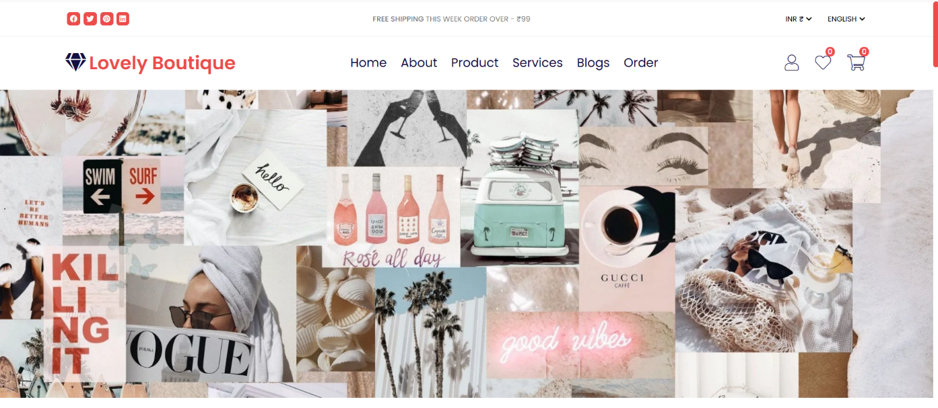

### Page 2: (about.html)

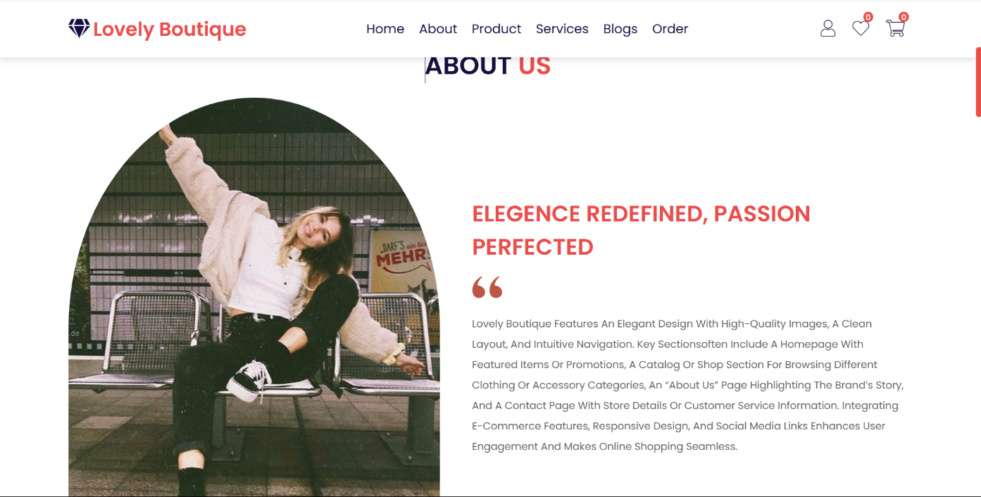

### Page 3: (products.html)

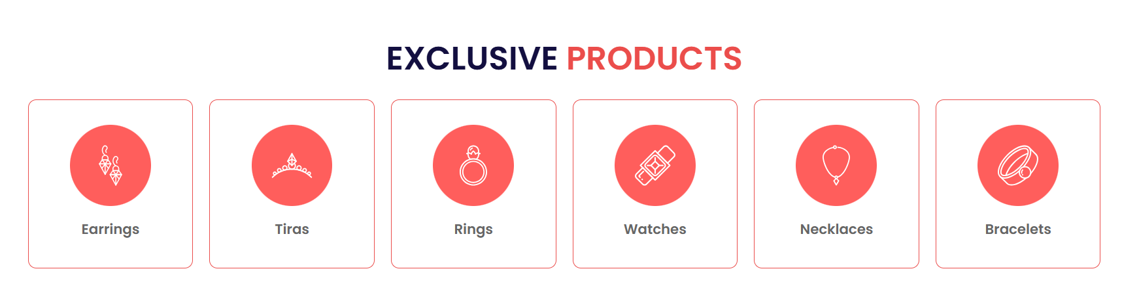

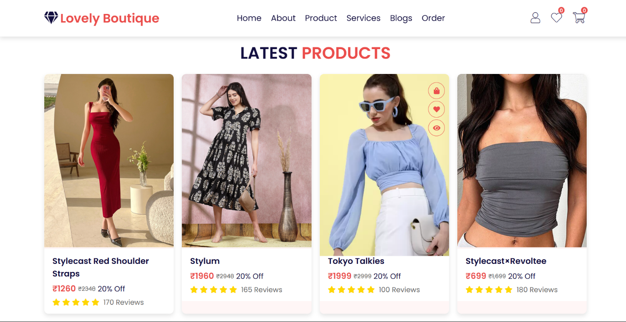

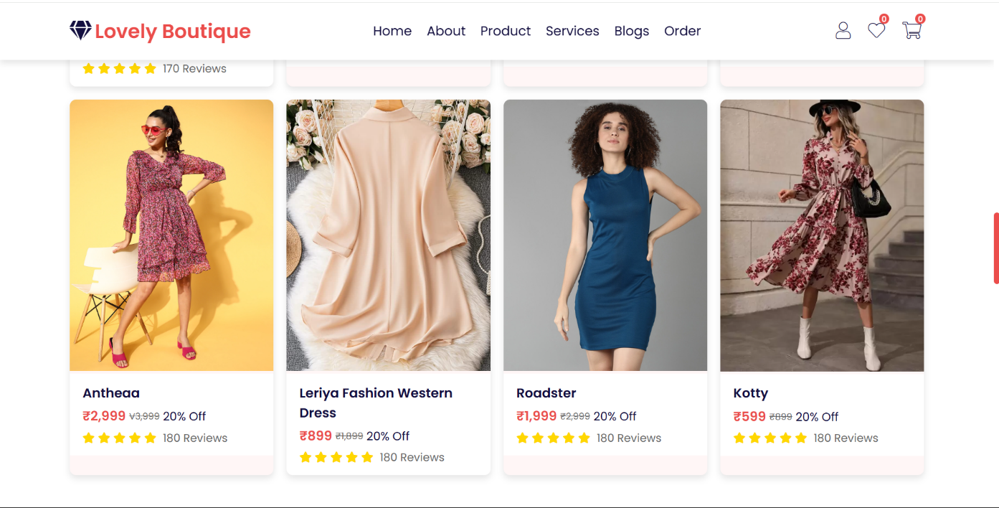

### Page 4: (services.html)

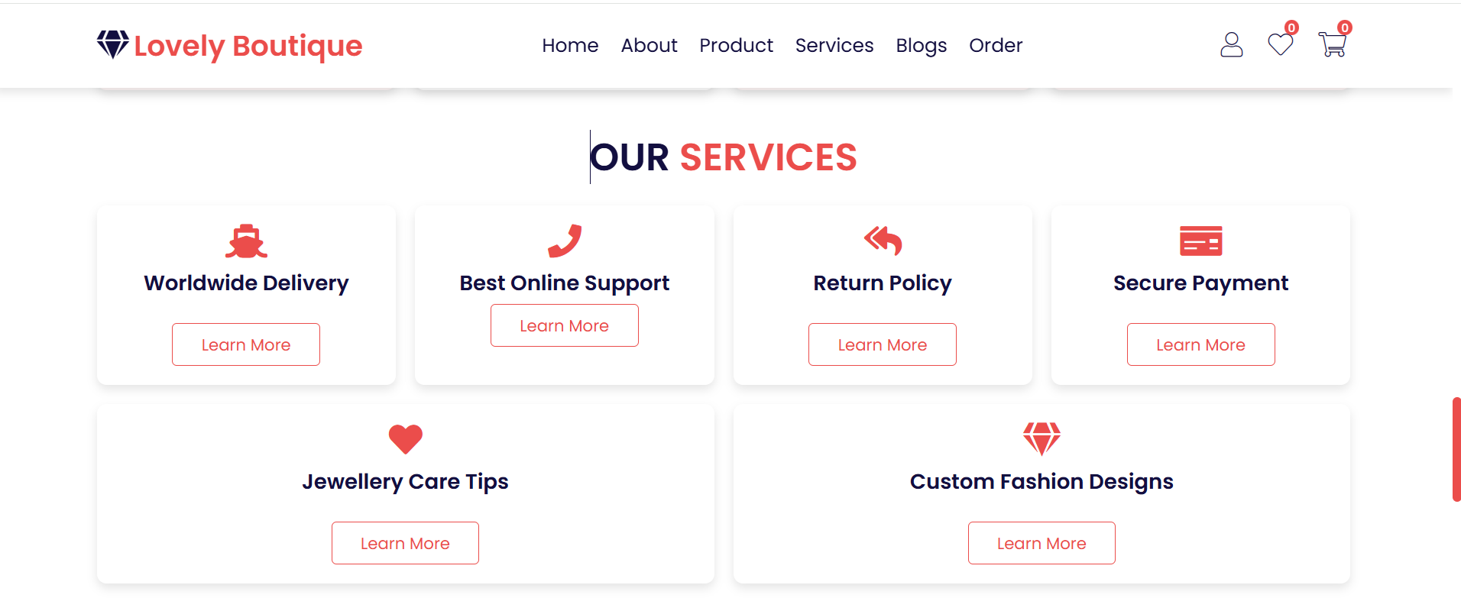

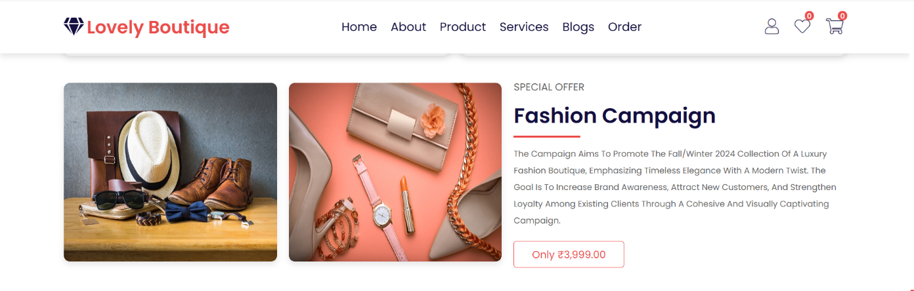

### Page 5: (blogs.html)

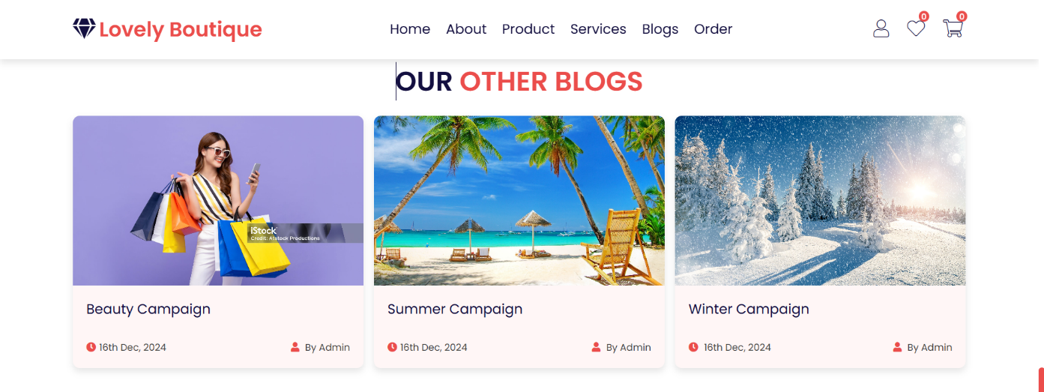

### Page 6: (order.html)

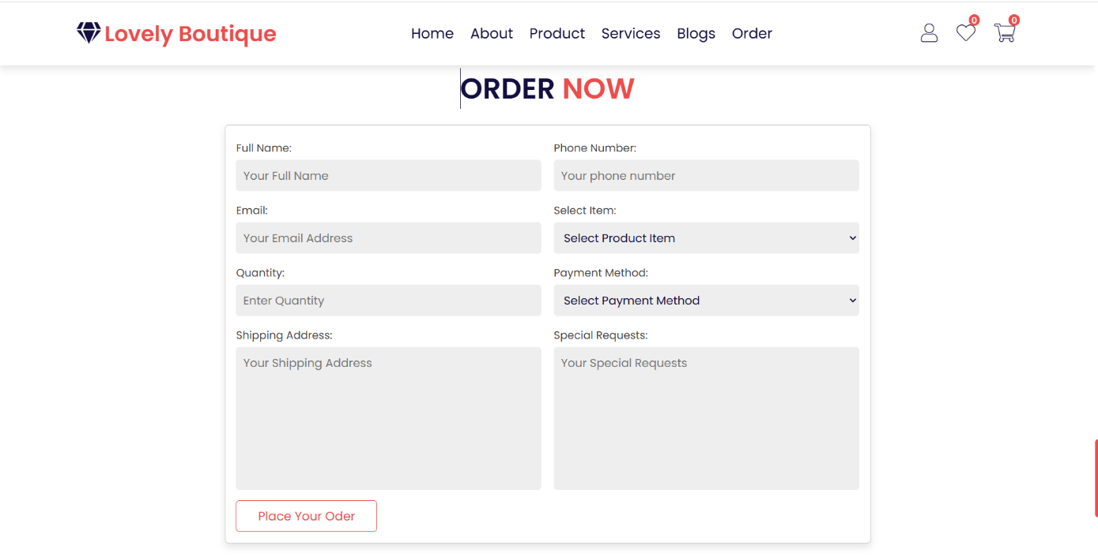

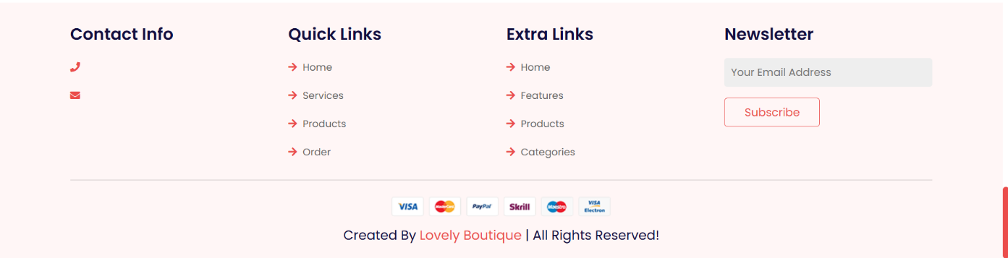

.

## List of Symbols, Abbreviations and Nomenclature

**Symbols and Abbreviations:**

1. **<!DOCTYPE html>**: Declaration that defines this document as an HTML5 document.
2. **<html>**: Root element that wraps all the content on the page.
3. **<head>**: Contains meta-information about the document, such as its title and links to stylesheets.
4. **<meta>**: Tag used to specify metadata about the HTML document (e.g., charset, viewport).
5. **<title>**: Sets the title of the document, which is displayed in the browser's title bar or tab.
6. **<link>**: Used to link external resources like stylesheets.
7. **<body>**: Contains the content of the HTML document that is visible to users.
8. **<header>**: Represents introductory content or navigational links.
9. **<nav>**: Defines a set of navigation links.
10. **<ul>**: Stands for "unordered list," used to create a list of items.
11. **<li>**: Stands for "list item," used within <ul> or <ol> to define each item.
12. **<strong>**: Indicates that the text is of strong importance, typically rendered in bold.
13. **<img>**: Tag used to embed images in the document.
14. **<footer>**: Represents the footer for a section or page, typically containing copyright information or links.
15. **©**: HTML entity representing the copyright symbol (©). **Nomenclature:**

* **CSS (Cascading Style Sheets)**: A stylesheet language used to describe the presentation of a document written in HTML or XML.
* **HTML (Hyper Text Markup Language)**: The standard markup language for creating web pages.
* **Viewport**: The user's visible area of a web page.
* **Metadata**: Data that provides information about other data, such as the character set or viewport settings in HTML.
* **Attributes**: Additional information provided in HTML tags, such as ‘**src’** for images or ‘**href’** for links.

## References

1. **MDN Web Docs** - Comprehensive documentation on web technologies.
2. **freeCodeCamp** - Interactive coding tutorials and exercises.
3. **Codecademy** - Interactive lessons on web development.
4. **Khan Academy** - Free courses on computer programming and web development.
5. **Coursera** - Courses from universities on web development topics.
6. **Udemy** - Wide range of paid and free courses on web development.
7. **HTML Dog** - Tutorials and references for HTML, CSS, and JavaScript.
8. **Tutorialspoint** - Tutorials on various programming languages and web technologies.
9. **GeeksforGeeks** - Tutorials, articles, and coding challenges on web development.
10. **CSS-Tricks** - Articles and guides focused on CSS and web development.

Project Done by:

P. L. N. Priya

K24AN

50